**JOBBHUB WEB APPLICATION**

1. **PROBLEM STATEMENT**

This web application purpose is to let the users search for right job by effectively browsing over hundreds of job opportunities at world leading MNC companies in the market. Its sole motive is to act as a bridge fulfilling the gap between the job seekers and job providers. This website is designed as a one stop solution to your job search.

1. **FUNCTIONAL REQUIREMENTS**

The JOBBHUB Application should provide all the functionalities that are listed below:

* **The user directly lands to login page.**



Here he can either directly login with valid credentials or can click on the register button if he is a new user.

* **On clicking register button, new user can get himself registered.**

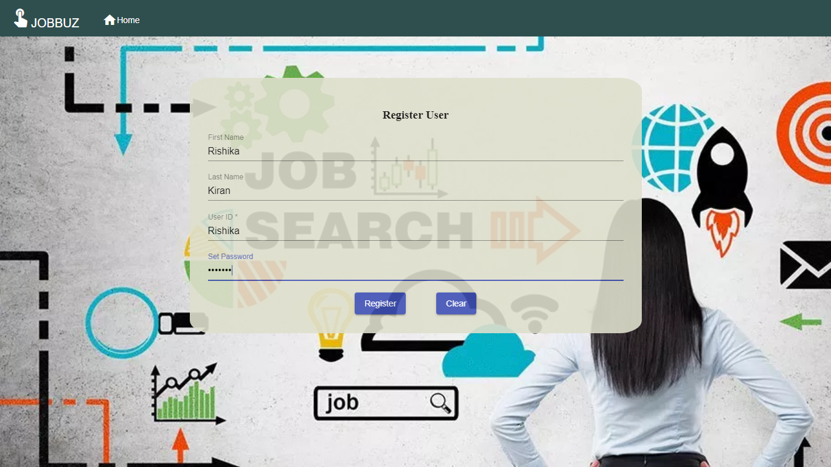

On successful registration user is automatically redirected to the login page.



* **On successful login user lands to the dashboard page with user ID and other options like view Bookmarks, Search, Logout, home buttons visible on header.**

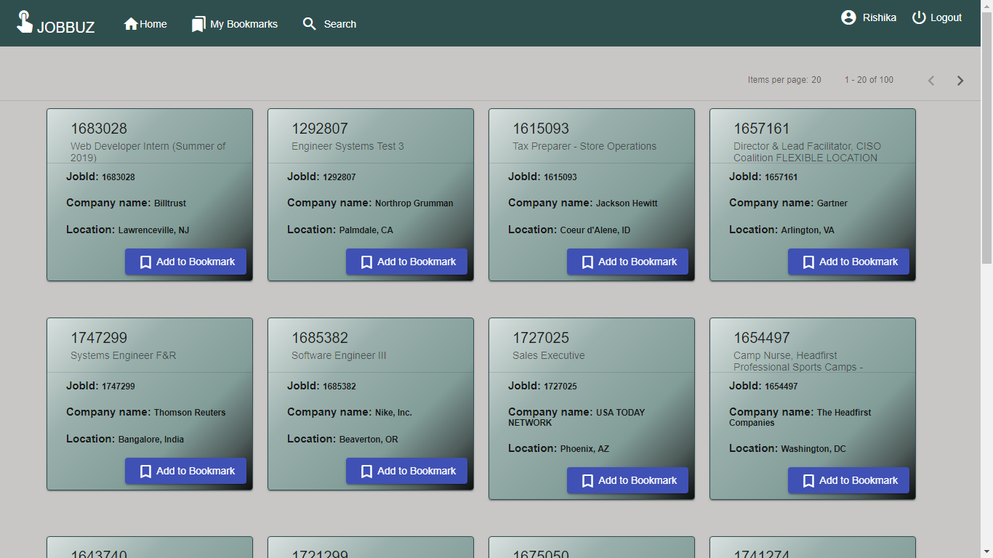

* **On clicking add to bookmark button, the job get successfully added to the bookmarks list.**

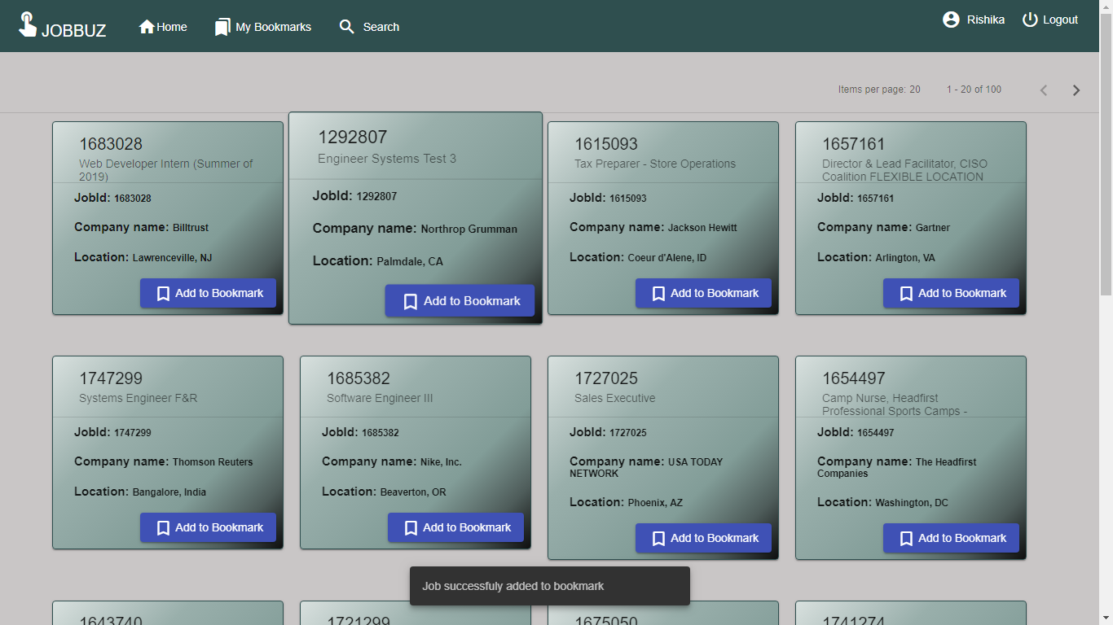

* **On clicking the card thumbnail, he can view all the details related to that job.**

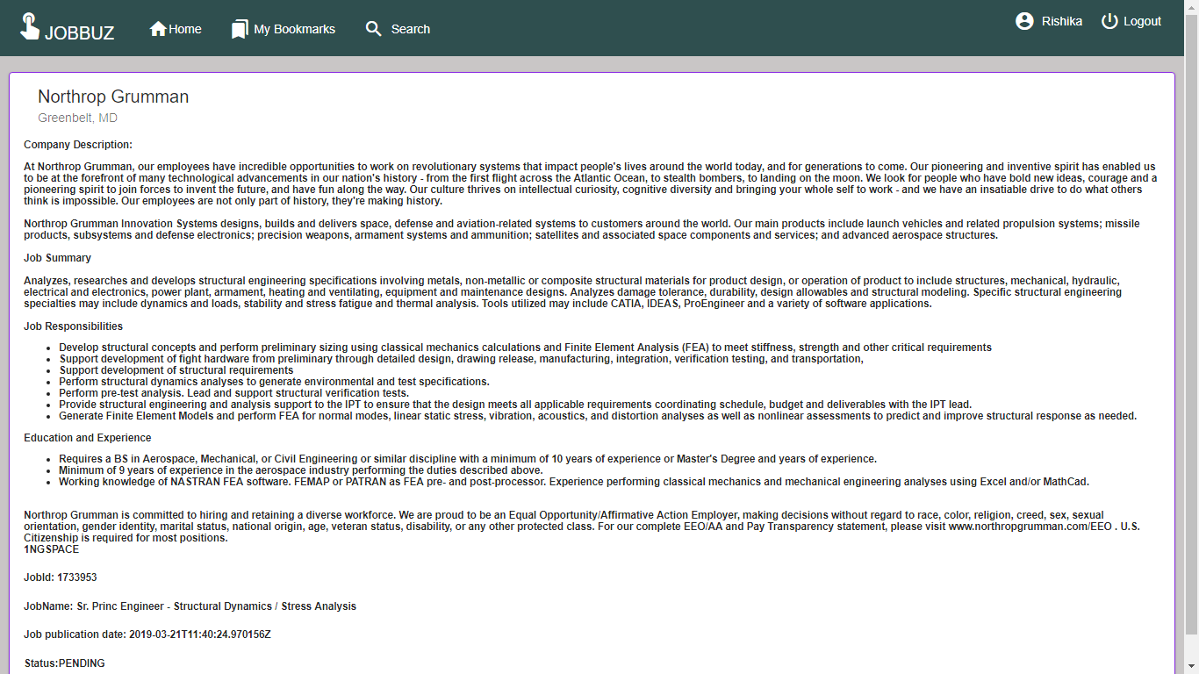

* **On clicking the bookmarks button the user is able to view all the jobs that are added to his bookmark.**

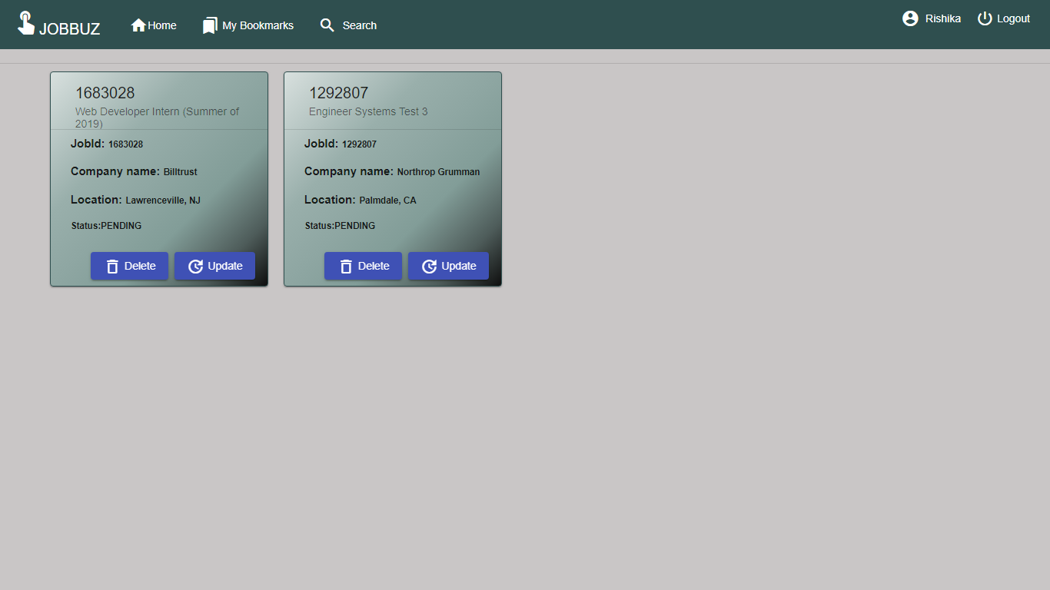

In bookmarks he can delete the job.

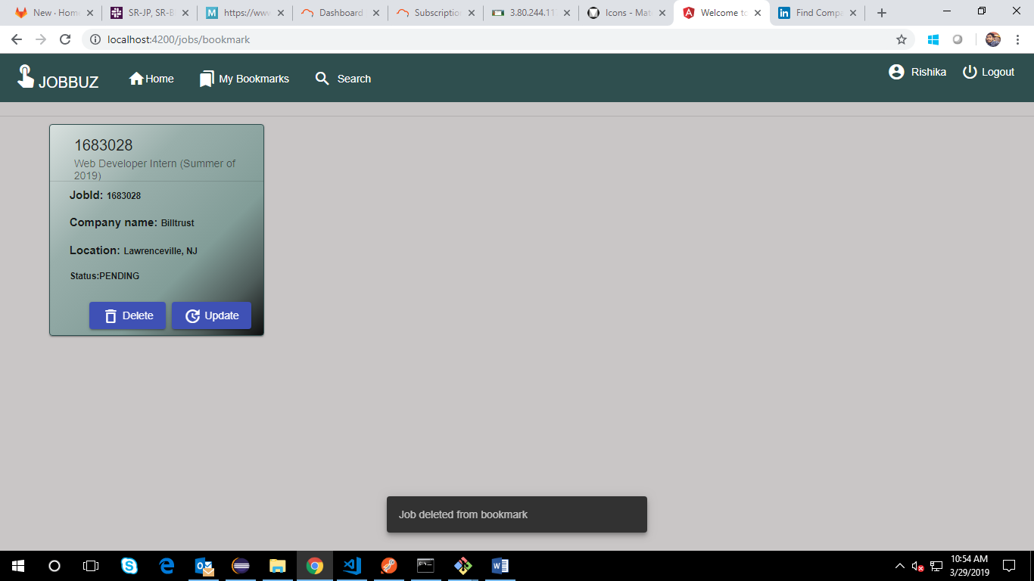

The user can also update status of job.

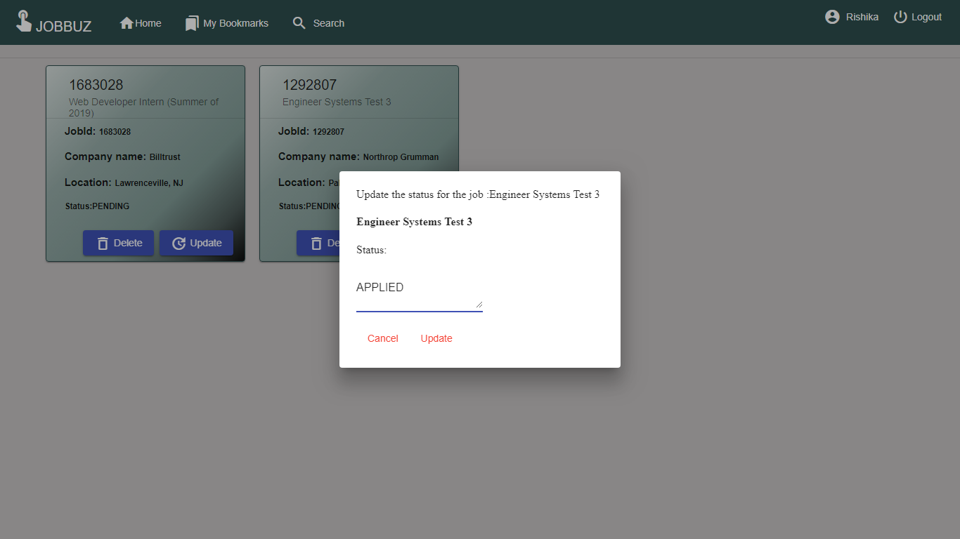

The status of jobs gets reflected on the page without reloading it.

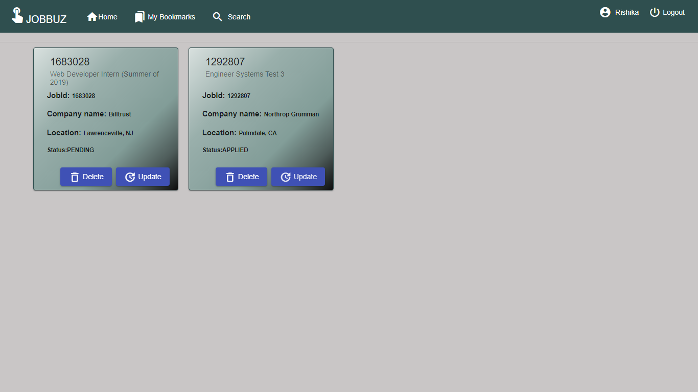

* **The user can also do search of jobs based on category.**

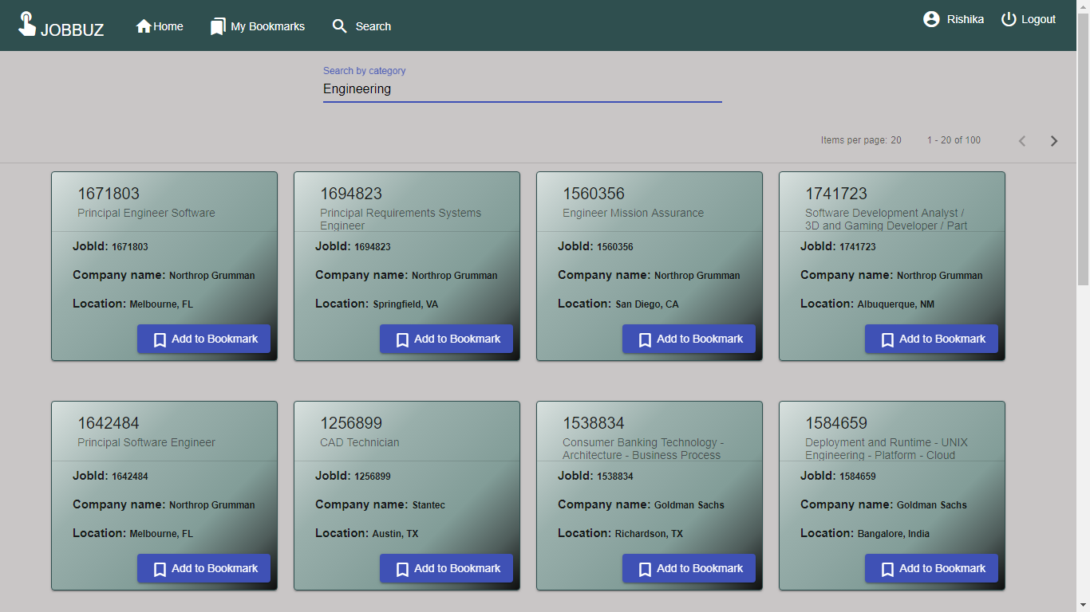

* **The user is currently viewing 20 results per page. For more jobs he can navigate using the pagination provided in screen**

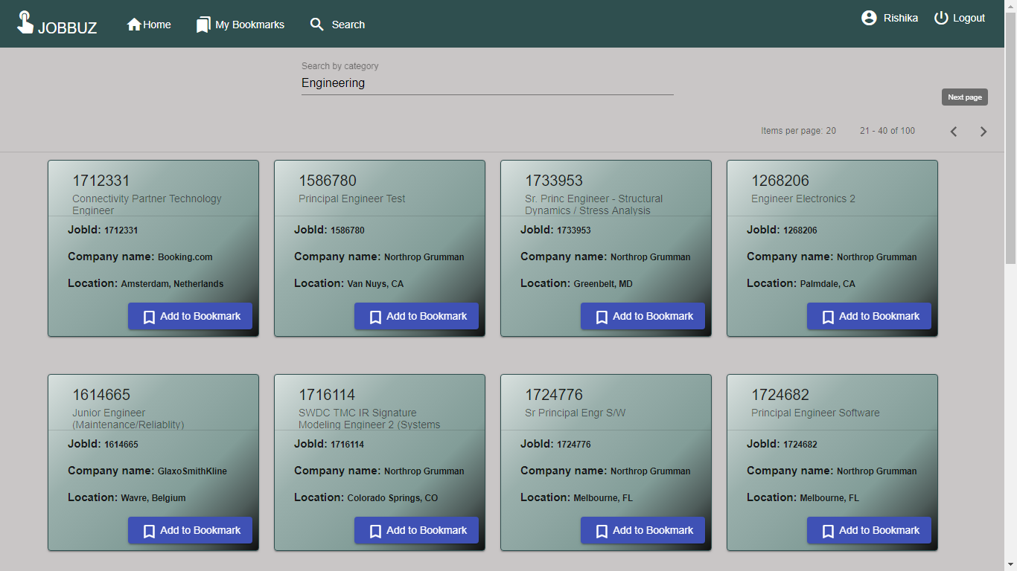

* **On clicking the logout button the user is redirected to the login page.**



1. **FUTURE GOALS**

* On clicking the job thumbnail on search results page and dashboard, job description gets displayed. The user should can have option to directly add jobs from here with buttons available at the bottom of job description.
* On clicking the job thumbnails in the bookmarks page, job description gets displayed. The user should can have option to directly delete and update jobs from here with buttons available at the bottom of job description.
* The job thumbnails can have logo of companies and a background image displayed depending upon the category of the job.
* The tags can be included such as number of people who applied for this job.
* The search options is currently applicable only by category. It can be extended to search by company and location.